Intermolecular forces and physical properties

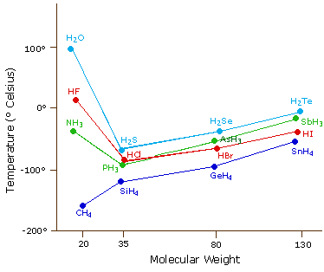
Graph 1: Boiling point (BP) of molecules containing hydrogen in group 14, 15, 16 and 17.
- From your understanding of intermolecular forces explain fully the apparent anomalies in the results above.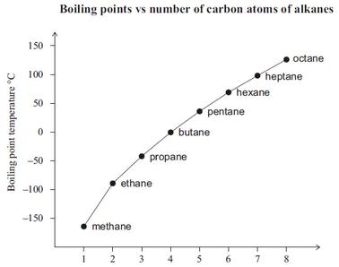
No. of Carbons
Graph 2: BP of alkanes vs No of carbons
- From your understanding of intermolecular forces explain fully the trend shown in graph 2 above.
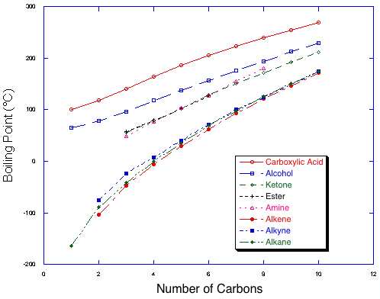
Graph 3: BP of different organic molecules vs No of carbons.
- From your understanding of intermolecular forces explain fully the reason alcohols have much higher boiling points than alkanes as shown in graph 3.

