Your task is to write a research paper in which you select and analyse a real application to illustrate the concepts and principles involved in the selected topic.

The following schematics give a suggested approach to the completion of the task.

Figure 1 below is a structured approach as to how this might be achieved.

Conduct a preliminary literature/internet search based upon one of the suggested topics, contexts encountered this term or an area of particular interest

Define an application/research focus

Deconstruct the application/research focus

Identify underlying physics concepts/ideas.
Concept D
Concept C
Concept B
Concept A

Demonstrate an understanding of the underlying physics concepts/ideas

Reconstruct the application/research focus showing how, specifically, the identified physics concepts/ideas are linked to your application/research focus and to each other. You need to be a little discriminating in deciding how, and to what extent, the identified concept ties into your selected application/research focus

Figure 1

There are a number of different genres that might be used in addressing the task. These include, for example, persuasive and expository essays. The particular genre used will depend upon the selected topic for example; the following statement might form the basis for a persuasive essay:

“The laws of chemistry may be used to refute, on a scientific basis, the theory of evolution and support the position of creationists”.

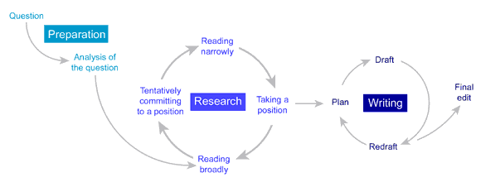
The Essay Writing Process.
Figure 2
http://unilearning.uow.edu.au/essay/1b.html

Figure 2 is a diagrammatic representation of the processes involved in writing an essay. Within the context of this task you may substitute “Selecting an application/research focus” for “Taking a position” if doing a research paper as opposed to a persuasive essay but the approach outlined above is a reasonable representation of the process to be followed.
Research Essay Structure – General Guide.

Introductory paragraph
The introductory paragraph should also include the thesis or statement that is a mini-outline for the essay. This is where the writer establishes the intention of the essay and informs the reader of what the paper is about. The last sentence of this paragraph should also include a transitional sentence that moves the reader to the first paragraph of the body of the essay.

Body paragraphs
The first sentence should contain a link to the transitional sentence from the previous paragraph. The subject for this paragraph should be in the first or second sentence and should relate to the thesis statement in the introductory paragraph. The last sentence in this paragraph should include a transitional statement that ties into the next paragraph of the body. Remember, only one idea/concept per paragraph. If you change ideas, start a new paragraph.

Concluding paragraph/s
These paragraphs are the summary paragraphs. It is important to restate the thesis and the supporting ideas in an original and powerful way as this is the last chance the writer has to convince the reader of the validity of the information presented.

These paragraphs should include the following:
- a restatement of the thesis statement, using some of the original language or language that "echoes" the original language. (The restatement, however, must not be a duplicate thesis statement.)
- a summary of the main points from the body of the essay and how they link to the thesis.
- a final statement that gives the reader signals that the discussion/presentation has come to an end. (This final statement may be a "call to action" in a persuasive essay.)
Referring back to Figure 1, if the nature of the task is a research essay then it is important to show how the identified concepts/ideas link back to the thesis statement.

Bibliography
To provide credibility to your argument you will need to present a Reference List and a Bibliography. Students treat these as two fairly unimportant aspects of the writing. However, you should see them as a way to bolster your argument and a way to provide evidence that you have engaged in the research process (to help authenticate the work as being your own). They also constitute a proof that you have consulted more than just one source or format (not just the internet, but books and journals for example).
References are used to acknowledge the source of comments, quotations, diagrams, photos and so on. Citation of primary sources establishes that you have gone to the trouble of finding the original source of the material rather than rely on someone else’s report of it. Citations show that your argument rests on solid foundations and that your comments should not be treated lightly.
A bibliography is a list of sources that you have consulted during your research. It is different to a Reference List in that you can cite sources that were read but not quoted.

