Preparation of Esters

Esters are a group of organic compounds best known for their interesting odors and flavors. Many natural odors and flavors were discovered to be esters and therefore, many synthesized esters are used in perfumes and foods.
An ester has the functional group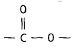, which is also known as an ester link. In the laboratory, an ester is usually formed from the reaction of a carboxylic (organic) acid and an alcohol, giving an ester and water as the products. This is an example of a condensation reaction, in which two molecules link up by the elimination of a small molecule between them; in this case, water.

We can write a general equation for the formation of esters as follows:
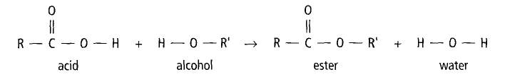
Here, R and R’ represent any alkyl group, of general formula C_{n}H_{2n+1}. Examples would be methyl (CH₃-), ethyl (C₂H₅-), or propyl (C₃H₇-). R and R’ can also represent any aryl group (one that contains a benzene ring) such as phenyl (C₆H₅-).

Naming Esters
The first part of the name of an ester is derived from the alkyl or aryl group of the alcohol used and the second part is from the carboxylic acid, using the ending -oate. As an example, if ethyl alcohol (ethanol) combines with propanoic acid, the resulting ester is named ethyl propanoate. The aroma of oranges is attributed to octyl ethanoate (formed from octanol and ethanoic acid) and apricots have an aroma because of the presence of pentyl butanoate (formed from pentanol and butanoic acid).

Reaction Conditions
The reaction between the alcohol and acid is rather slow at room temperature. In order to speed it up and get an appreciable yield in the time available, you will use a temperature of about 60°C and add sulfuric acid to act as a catalyst in the reaction. In this experiment, the class will prepare six esters and carefully smell them to see if there are any odors you recognize.

odors: smells synthesized: made in the laboratory
elimination: remove formation: making or production of
is attributed to: is said to come from appreciable: good, decent
catalyst: a chemical that is added to a reaction to speed it up
Purpose

- To synthesize several esters and try to identify the odor of each.
- To write the chemical equations for the formation of each ester using structural formulas.

Materials
Equipment Chemical Reagents
2 test tubes Methanol
Test tube rack pentanol
Safety goggles 1-propanol
Scale 1-octanol
Hot plate acetic acid
2 x 250 mL beakers salicylic acid
10 mL graduated cylinder Concentrated sulfuric acid
Thermometer
Lab apron
Beaker tongs

Procedure

Note: Your group will be assigned 2 of the 4 esters to make and then you will need to make observations on the other groups’ esters.

- Put on your lab apron and safety goggles.
- Label the test tubes with masking tape according to the numbers you were assigned and place them in the test tube rack.
- Into the appropriate test tube, pour the correct amount of alcohol and add the corresponding carboxylic acid as indicated in Table 1 below (~20 drops is 1mL; use the scale to measure the solid salicylic acid).
- Add 4 drops of concentrated sulfuric acid to each test tube.

Table 1 –Reagents for preparation of esters

Test Tube | Carboxylic Acid | Alcohol
1 | 1.0 ml acetic acid | 1.0 mL pentanol
2 | 1.0 ml acetic acid | 1.0 mL 1-propanol
3 | 1.0 g salicylic acid | 1.0 mL methanol
4 | 1.0 ml acetic acid | 1.0 mL 1-octanol

- Pour about 150 mL of tap water in a 250 mL beaker. Place the test tubes in the water and heat the water on a hot plate to a temperature of about 60ºC. Leave the test tubes in the hot water bath for 15 minutes. Be careful not to overheat the solutions. If the water is getting too warm, remove the beaker from the hotplate using beaker tongs and place it on a ceramic tile until it cools down.
- Cool the test tubes by putting them in cold water in another beaker.
- Add 5 mL of distilled water to each of the test tubes.
- Carefully note the odor of the contents of each of the test tubes in your copy of Table 2 in your notebook. Hold the test tube about 30 cm away from your nose and gently waft the vapors towards your nose without inhaling deeply. Each of the odors should be somewhat familiar to you. Alternatively, the contents of the test tube may be poured into a beaker half full of water and the odor above it detected carefully.
- Dispose of all materials following the reagent disposal instructions.
- Before leaving the laboratory, wash your hands thoroughly with soap and water.

Observations
Table 2 – Odors of Esters

Test Tube | Name of Ester Formed | Odor
1
2
3
4

Post Lab Considerations
The reason for adding water to the contents of the test tube is to separate the esters from the reactants used. Esters are soluble in alcohol, but insoluble in water, and they generally have a density less than that of water, enabling them to separate and float to the top of the liquid mixture. This makes the detection of the odor more reliable.

To obtain a better understanding of the chemical changes that occur, you must write the balanced equations for these reactions using structural formulas. The structures of the alcohols and carboxylic acids used in this experiment are as follows:

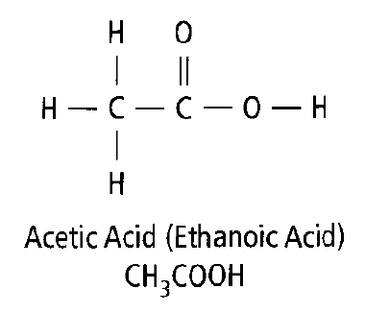 | 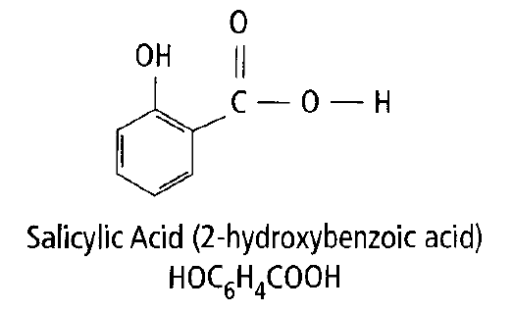
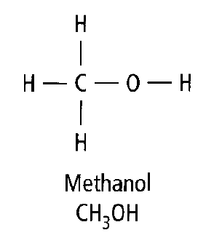 | 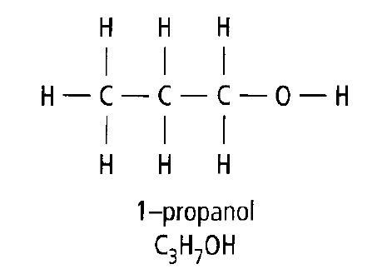
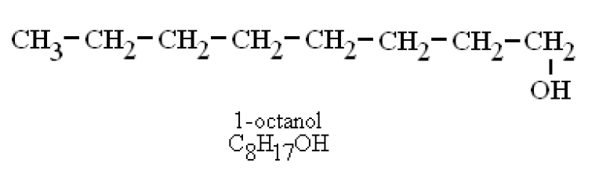 | 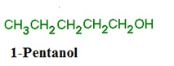

Questions

1. Using structural formulas, write the equations for the reactions that occurred in each of the test tubes. Use a piece of your lined paper for this.

