Exercise: Representing organic compounds

1. For each of the following organic compounds, give the condensed structural formula and the molecular formula.

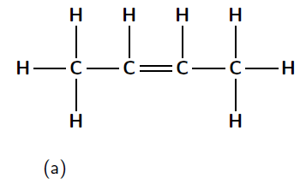 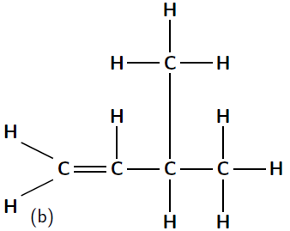

1. For each of the following, give the structural formula and the molecular formula.
   1. CH3CH2CH3
   2. CH3CH2CH(CH3)CH3
   3. C2H6O
2. Give four possible structural formulae for the compound with a molecular formula of
   1. C6H14.
   2. C5H8
   3. C4H10O

Exercise: Isomers

Match the organic compound in Column A with its isomer Column B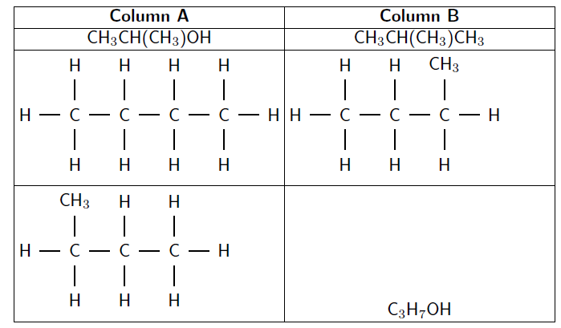

**Steps to naming an organic molecule:**

1. Draw the compound from its condensed structural formula or molecular formula
2. Identify the functional group
3. Find the longest carbon chain
4. Number the carbons in the longest chain
5. Look for any branched groups, name them and give their position on the carbon chain
6. Combine the elements of the name into a single word in the alphabetical order of branched groups; prefix; name ending according to the functional group.

Example:



Question: Give the IUPAC name for the following compounds:

1. CH3CH(CH3)CH(CH3)CH3
2. CH3CHCHCH3
3. 
4. 

Question: Give the structural formula of each of the following organic compounds:

1. pentan-3-ol
2. butan-2,3-diol
3. 2-methyl-propanol